

Group #1

PARSd

The TEAM:

Ankur Bag

Priyank Agrawal

Rajat Agrawal

Sabrish Ramamoorthy

Business Requirement Document

For

Patient Model

Professor: Vincent Lattuada

Information Systems

Northeastern University

# **Version History**

|  |  |  |  |
| --- | --- | --- | --- |
| **Date** | **Version No.** | **Sections Affected** | **Comments** |
| 03/30/2016 | 0.1 | All | Individual Addition of Entities |
| 03/31/2016 | 1.0 | All | Created the Draft Version of the system |
| 04/06/2016 | 1.1 | All | Created the Draft Version of the system |
| 04/12/2016 | 1.2 | Introduction, Entities & Attributes | Created the Draft Version of the system |
| 04/13/2016 | 1.2 | Entities & Attributes, In-scope and out-of-scope | Created the Draft Version of the system |
| 04/14/2016 | 1.2 | Entities & Attributes, Relationships, ERD | Created the Draft Version of the system |
| 04/18/2016 | 1.2 | Added new Entities and Attributes | Created the Draft Version of the system |
| 04/18/2016 | 1.2 | Changes in Relationship shared between entities | Created the Draft Version of the system |
| 04/21/2016 | 1.2 | Introduced new attribute in Bed Assignment and change in Relationship | Created the Draft Version of the system |
| 04/21/2016 | Final | Final | Created the Final Version of the system |

Contents

**Version History** 3

**1. Introduction** 9

**1.1 System Overview** 9

**1.2 Intended Audience** 10

**1.3 In-Scope** 11

**1.4 Out-of-Scope** 12

**2. Entity Relationship Diagram** 13

**3. Entities & Attributes** 14

**3.1 patient** 14

**3.2 address** 17

**3.3 social_habits** 18

**3.4 family_history** 19

**3.5 health_care_proxy** 20

**3.6 allergy_lk** 22

**3.7 disease_lk** 23

**3.8 patient_disease_summary** 24

**3.9 immunization_details_lk** 25

**3.10 patient_immunization** 26

**3.11 disability_lk** 27

**3.13 patient_disability** 28

**3.14 insurance_lk** 29

**3.15 patient_insurance_history** 30

**3.16 patient_surgery_history** 31

**3.17 patient_event** 32

**3.18 vital_signs** 33

**3.19 doctor** 34

**3.20 prescription** 35

**3.21 medication_lk** 36

**3.22 treatment** 37

**3.23 patient_surgery_details** 38

**3.24 procedure_lk** 39

**3.25 lab_test_history** 40

**3.26 lab_test_lk** 41

**3.27 lab_test_images** 42

**3.28 bed_assignment** 43

**4. Relationships** 44

**4.1 patient_has_address** 44

**4.2 patient_has_socialhabits** 44

**4.3 patient_has_familyhistory** 44

**4.4 patient_has_healthproxy** 44

**4.5 patient_has_allergy** 45

**4.6 patient_has_disease** 45

**4.7 patient_is_immuned** 45

**4.8 patient_has_disability** 45

**4.9 patient_has_insurance** 46

**4.10 patient_undergoes_surgery** 46

**4.11 patient_has_event** 46

**4.12 doctor_serves_event** 46

**4.13 patient_has_vitals** 47

**4.14 patient_given_prescription** 47

**4.15 prescription_has_medication** 47

**4.16 patient_undergoes_treatment** 47

**4.17 patient_undergoes_surgery** 48

**4.18 patient_gives_labtest** 48

**4.19 patient_has_bedassigned** 48

**5. Glossary of Terms** 49

# **1. Introduction**

## **1.1 System Overview**

* Patient data model is designed specifically for the Healthcare industry that includes the most important clinical facts required to ensure safe and secure healthcare.
* The Patient model captures all of the entities that are required for any In-patient and Out-patient at the health care provider facility.
* The Patient who just visits the health care provider for a regular checkup, follow-up or test is an Out-patient and the Patient who gets admitted in the facility of the health care prover and treated is an In-Patient.
* The Patient will be having his/her medical record like vital signs, tests, insurance information, etc. maintained by the health care provider and he/she will also be having his emergency contact, health care proxy information stored.
* This model organizes the entities into a database of coherent tables that together capture and store all data in a structured format which can later be used to create various applications and extend in near future.
* This Patient Model is more improved and completely new version from previous group draft version of the Patient model.
* There are several other scenarios/entities/relationships discussed in the remainder of the document.

## **1.2 Intended Audience**

* This model can be implemented by various health care providers in the health care industry of any scalability be it large scale providers like hospitals or small scale providers like clinics.
* This model can be implemented and all the necessary information about the incoming patient can be stored in the database for future references.

## **1.3 In-Scope**

|  |  |
| --- | --- |
| IS001 | Capturing **Patient personal details** like Patient Name, Age, Gender, Location etc. |
| IS002 | Capturing **Patient Medical History** with consist of all the various health records. |
| IS003 | We are also maintaining **Family history** of patient where we will capture the family member details and any medical diseases from which member suffered from or suffering from. |
| IS004 | **Vaccination/Immunization** details taken by Patient. |
| IS005 | **Allergies** from which the Patient prone to have. This Allergy can be occur due to intake of medicine or food. |
| IS006 | **Patient Insurance details** with the type of Insurance. |
| IS007 | Capturing **Patient Medication** consisting of medicine details with dosage intake. |
| IS008 | **Emergency Contact details** of the primary contact of Patient in case of any emergency. |
| IS009 | We will also capture the **primary physician care details** related to each patient. |
| IS010 | Capturing **Vital Sign** which consist of the sign like blood pressure, heart rate, etc. which changes frequently and help to take medical decision for a patient. |
| IS011 | We will also capture the type of **visit associated with the Patient event** the patient had with a doctor and duration of stay if the patient is admitted (emergency). |
| IS012 | We are capturing various **medication and surgeries details** for a particular Patient. |
| IS013 | Data related to **bed assignment** in case of patient stay will be captured. |
| IS014 | Data related to **patient Lab result test** are also captured. |
| IS015 | We are capturing **Visiting Procedures** (Health related decision) taken for the Patient. |
| IS016 | All the **medical test** taken by the patient will be captured and stored in dB with their outcome. |
| IS017 | **Doctor details** will be captured. |
| IS018 | **General medication and surgery information** will be stored. |
| IS019 | **General Lab test** with their description. |
| IS020 | **Disability** Level of Patient. |
| IS021 | Patient Event table will determine the **type of patient.** |
| IS022 | We are maintaining **Address details** with every patient such as state and county information. |
| IS023 | **Health Care proxy** will take decision on behalf of patient during emergency. |
| IS024 | **Social habits such** as drinking and smoking habits will be captured and maintained. |
| IS025 | **Inpatient** will be associated with type of patient who visit the doctor for routine check-up. |
| IS026 | **Outpatient** will also be associated with the patient who stays for more than 24 hours. |
| IS027 | **Inpatient** can also assigned **a bed.** |
| IS028 | **Treatment** details given to patient during visit will be captured and stored. |
| IS029 | **Prescription details** given by doctor will be stored with the medication details. |
| IS030 | **Disease summary** will be maintained for all patients. |
| IS031 | Organization providing the insurance will be maintained**.** |
| IS032 | Diseases associated with a particular patient with its severity will be captured. |

## **1.4 Out-of-Scope**

|  |  |
| --- | --- |
| OS001 | We are not offering history **based rate cards** for continuing patients. |
| OS002 | We are not **scheduling regular checkups** for patients according to their age slot. |
| OS003 | We are not capturing any **Insurance claim history**. |
| OS004 | **Food and nutrients intake** are not our concern at the moment. |
| OS005 | We are not concern with **levels of patient care,** such as emergency, or normal level. |
| OS006 | We are not maintain any **inventory** of medicines. |
| OS007 | For now test performed by concern **lab person** are not in scope. |
| OS008 | We are not concerned with **Doctor schedule**. |
| OS009 | We are not concerned with **patient billing** details. |
| OS010 | We are not concerned with **Infrastructure** details. |
| OS011 | We are not capturing the **Staff details** present in the organization. |
| OS012 | We are not concerned with **address details of Heath care provider**. |
| OS013 | We are not concerned with **Employment Status** of the patient like SSN details etc. |
| OS014 | **Referral details** are not being captured. |
| OS015 | We are not capturing the **visitor’s details** who visit the patient. |
| OS016 | We are not capturing the **patient feedback** details given by patient during his discharge. |
| OS017 | **Sponsorship details** will not be captured. |
| OS018 | **Patient Visit Slip** is not maintained. |
| OS019 | **Patient Image** will not captured and maintained in database**.** |
| OS020 | **Anesthesia details** are not of concern as per now. |

# **2. Entity Relationship Diagram**

# C:\Users\priya\Downloads\patient.png

# **3. Entities & Attributes**

## **3.1 patient**

Patient is a person receiving or registered to receive medical treatment from a health care provider. In this model Patient is the key entity and it can be of two types that are in-patient and out-patient. This table captures the basic information of the patient who visit the health care provider.

|  |  |  |  |
| --- | --- | --- | --- |
| **Attribute** | **Constraint/****Key** | **Data Type** | **Description** |
| patient_UPI | NN/ PK | Char (6) | This item is the unique identification of the patient. Thus it is the primary key of this entity. UPI is Unique Patient Identification code which is also maintained on a national level by the United States government. |
| patient_fname | NN | Varchar (20) | This item holds the first name of the patient. |
| patient_lname | NN | Varchar (20) | This item holds the last name of the patient. |
| patient_mname | - | Varchar (20) | This item holds the middle name of the patient. |
| patient_dob | NN | Date | This item holds the date of birth of the patient in the format MM/DD/YYYY. |
| gender | NN | Char (1) | This item holds the sex of the patient which can either be M for male and F for female. |
| blood_group | - | Char (3) | This item holds the blood group of the patient from a predefined set of values that are AB+, AB-, A+, A-, B+, B-, O+ and O-. |
| disability_status | NN | Char (1) | This item holds the disability status of the patient which can either be Y for yes and N for no. |
| marital_status | NN | Varchar (10) | This item captures the marital status of the patient which can be Single, Married, Divorced, Common Law. |
| cell_phone | NN | Char (10) | This item captures the phone number of the patient. |
| home_phone | - | Char (10) | This item captures the phone number of the patient. |
| patient_pcp_name | - | Varchar (40) | This item holds the primary care physician’s name of the patient. |
| emergency_contact_name | - | Varchar (40) | This item holds the name of primary emergency contact person who must be contacted first in case of any emergency. |
| emergency_contact_number | - | Char (10) | This item holds the primary emergency contact person’s phone number. |
| emergency_contact_relationship | - | Varchar (20) | This item captures the relationship of primary emergency contact person with the patient. For example spouse, father, mother, son, etc. |
| address_id | NN/FK | Int | This item captures the foreign key which references to the patient’s address in the address table. |

**Sample Data:**



## **3.2 address**

The ‘address’ entity holds the information about the address of the patient who visits the health care provider. The address entity serves as a lookup table which benefits in reducing the redundancy of data in scenarios of two patients sharing the same address.

|  |  |  |  |
| --- | --- | --- | --- |
| **Attribute** | **Constraint/****Key** | **Data Type** | **Description** |
| address_id | NN/PK | Char (6) | This item is the unique identification of the address of the patient. Hence it serves as the primary key for this entity. |
| street | NN | Varchar (40) | This item captures the information about the street where the patient resides. |
| city | NN | Varchar (20) | This item captures the information about the city where the patient resides. |
| state | NN | Char (2) | This item captures the information about the state in which the patient resides. |
| zip-code | NN | Char (5) | This item captures the zip-code of the street where the patient resides. |
| country | NN | Char (2) | This item captures the information about the country in which the patient resides. |

**Sample Data:**

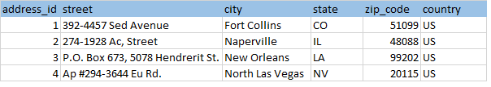

## **3.3 social_habits**

Social habit is a routine or behavior that is repeated regularly by a person in this case a patient. Habits like smoking and alcohol as well as drug intake are the most important factors that affect a patient’s health which is why they are being captured in this table.

|  |  |  |  |
| --- | --- | --- | --- |
| **Attribute** | **Constraint/** **Key** | **Data Type** | **Description** |
| smoking_habit | - | Char (1) | This item captures the information whether the patient has a smoking habit or not in the format of Y for yes of N for no. |
| smoking_years | - | Int | This item holds the record of number of years the patient has been smoking if he has a smoking habit. |
| alcohol_habit | - | Char (1) | This item captures the information whether the patient has an alcohol intake habit or not in the format of Y for yes of N for no. |
| alcohol_years | - | Int | This item holds the record of number of years the patient has been consuming alcohol if he has alcohol intake habit. |
| recreational_drugs | - | Char (1) | This item captures the information whether the patient has been consuming drugs or not in the format of Y for yes of N for no. |
| patient_UPI | NN/PFK | Char (6) | This item captures the foreign key which references to the patient’s detail in the patient table. It also serves as a primary key because this table cannot exist without the patient. |

**Sample Data:**

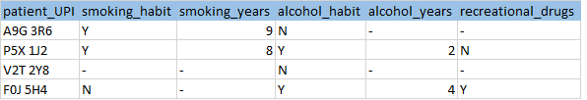

## **3.4 family_history**

A family health history refers to the health information about the patient’s close relatives and family members. Family health history is one of the most important risk factors for health problems like heart disease, stroke, diabetes, and cancer which a patient is more likely prone to which is why it is very important to maintain family history of the patient. This table captures all required information of the patient’s family members.

|  |  |  |  |
| --- | --- | --- | --- |
| **Attribute** | **Constraint/** **Key** | **Data Type** | **Description** |
| member_name | NN | Varchar (40) | This item holds name of the member from the family of the patient. |
| member_pateint_relationship | NN | Varchar (10) | This item captures the relationship that the family member shares with the patient which can be guardian, mother, father, wife, son, etc. |
| member_dob | NN | Date | This item holds the date of birth of the family member. Format - MM/DD/YYYY. |
| alive | NN | Char (1) | This item hold the record whether the family member is alive or not. |
| medical_conditions | NN | Varchar (50) | This item captures the last recorded medical condition of the family member in detail. |
| death_cause | - | Varchar (50) | This item record of cause of death of the family member only if the person is not alive anymore. |
| death_age | - | Int | This item captures the exact date at which the family member of the patient died. |
| patient_UPI | NN/PFK | Char (6) | This item captures the foreign key which references to the patient’s detail in the patient table. It also serves as a primary key because this table cannot exist without the patient. |

**Sample Data:**



## **3.5 health_care_proxy**

A Healthcare proxy is a person who is responsible for taking decision on behalf of patient during emergency situations when the patient is unable to take decisions himself. This entity holds all the necessary information of the healthcare proxy as required by the health care provider.

|  |  |  |  |
| --- | --- | --- | --- |
| **Attribute** | **Constraint/** **Key** | **Data Type** | **Description** |
| patient_UPI | NN/PFK | Char (6) | This item captures the foreign key which references to the patient’s detail in the patient table. It also serves as a primary key because this table cannot exist without the patient. |
| primary_agent_name | NN | Varchar (40) | This item holds the name of primary healthcare proxy who is responsible for taking decisions in emergency situations when the patient is unable. |
| primary_phone_number | NN | Char (10) | This item holds the phone number of the primary healthcare proxy. |
| primary_privileges | NN | Varchar (20) | This item captures the privileges of the primary health care proxy. |
| primary_start_date | NN | Date | This item captures the date from which the primary health care proxy is held valid to take decisions on behalf of the patient. Format - MM/DD/YYYY. |
| primary_end_date | NN | Date | This item captures the date till which the primary health care proxy is held valid to take decisions on behalf of the patient. Format - MM/DD/YYYY. |
| secondary _agent_name | - | Varchar (40) | This item holds the name of secondary healthcare proxy who is responsible for taking decisions on behalf of the patient if the primary proxy is unable. |
| secondary_phone_number | - | Char (10) | This item holds the phone number of the secondary healthcare proxy. |
| secondary _privileges | - | Varchar (20) | This item captures the privileges of the secondary health care proxy. |
| secondary _start_date | - | Date | This item captures the date from which the secondary health care proxy is held valid to take decisions on behalf of the patient. Format - MM/DD/YYYY. |
| secondary _end_date | - | Date | This item captures the date till which the secondary health care proxy is held valid to take decisions on behalf of the patient. Format - MM/DD/YYYY. |

## **Sample Data:**

## 



## **3.6 allergy_lk**

Allergy table holds the detail of different types of allergies that a patient may have. Allergy is a damaging immune response by the body to a substance, especially pollen, fur, a particular food, or dust, to which it has become hypersensitive. The allergy entity serves merely as a lookup table which benefits in reducing the redundancy of data in scenarios when two or more patients share the same allergy and hence nullifying duplicity of data.

|  |  |  |  |
| --- | --- | --- | --- |
| **Attribute** | **Constraint/Key** | **Data Type** | **Description** |
| allergy_id | NN/PK | Int | This item is the primary identification of the different allergies that exist in the health care provider’s database. |
| allergy_name | NN | Varchar (30) | This item holds the name of the allergy like a particular food allergy, drug allergy, nasal allergy, asthma etc. |
| allergy_type | NN | Varchar (20) | This item holds the type of allergy which the patient can have like food, air, cloth, smell, drug, chemical, etc. |

**Sample Data:**

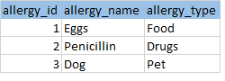

## **3.7 disease_lk**

A disease is a particular abnormal condition, a disorder of a structure or function that affects part or all of an organism. This entity serves merely as a lookup table which benefits in reducing the redundancy of data in scenarios when two or more patients have the same disease and hence nullifying duplicity of data

.

|  |  |  |  |
| --- | --- | --- | --- |
| **Attribute** | **Constraint/**  **Key** | **Data Type** | **Description** |
| disease_ICD_10 | NN/PK | Char (7) | This item serves as the unique identification for this entity. The ICD_10 is the International Classification of Disease maintained by WHO that is World Health Organization. It is followed universally. |
| disease_desc | NN | Varchar (255) | This item captures the description of the disease in detail. |

**Sample Data:**

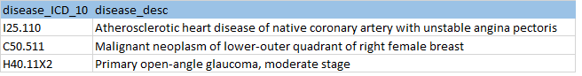

## **3.8 patient_disease_summary**

This entity captures the relationship between patient and the disease the patient has. The patient and the disease share a many to many relationship because of which this join table comes into existence. It also captures some other useful details as shown in the table.

|  |  |  |  |
| --- | --- | --- | --- |
| **Attribute** | **Constraint/**  **Key** | **Data Type** | **Description** |
| patient_UPI | NN/PFK | Char (6) | This item captures the foreign key which references to the patient’s detail in the patient table. It also serves as a primary key because this table cannot exist without the patient. |
| disease_ICD_10 | NN/PFK | Varchar (7) | This item captures the foreign key which references to the disease’s detail in the disease entity. It also serves as a primary key because this table cannot exist without the patient. |
| disease_status | NN | Char (1) | The item reflects whether the patient is currently suffering from the disease or not. |
| observation_date | NN | Datetime | This item captures the date at which the disease was found in the patient. Format - yyyy-mm-dd hh:mm:ss |
| symptoms | NN | Varchar (50) | This item holds the information about the symptoms that were seen in the patient who had the disease. |

## **Sample Data:**

## 

## **3.9 immunization_details_lk**

Immunization table holds the detail of different types of immunization that a patient may have taken in the past. The immunization entity serves as a reference table which benefits in reducing the redundancy of data in scenarios when two or more patients have been immunized from the same agent and hence nullifying duplicity of data.

|  |  |  |  |
| --- | --- | --- | --- |
| **Attribute** | **Constraint/**  **Key** | **Data Type** | **Description** |
| immunization_id | NN/PK | int | This item is the primary identification of the different immunizations that exist in the health care provider’s database. |
| immunization_name | NN | Varchar (30) | This item holds the name of the immunization like adenovirus, polio, anthrax, hepatitis, etc. |
| immunization_type | NN | Varchar (20) | This item holds the different types of immunization like bacterial or viral. |
| suggested_age | NN | Varchar (10) | This item holds the age group at which the immunization is suggested to be taken by a person to be most effective. |
| immunization_agent | NN | Varchar (50) | This item captures the information about the agent which the person immunized from after taking the immunization. |

**Sample Data:**

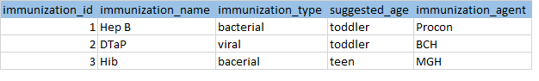

## **3.10 patient_immunization**

This entity captures the relationship between patient and the immunization the patient has taken. The patient and the immunization share a many to many relationship because of which this join table comes into existence. It also captures some other useful details as shown in the table.

|  |  |  |  |
| --- | --- | --- | --- |
| **Attribute** | **Constraint/**  **Key** | **Data Type** | **Description** |
| patient_UPI | NN/PFK | Char (6) | This item captures the foreign key which references to the patient’s detail in the patient table. It also serves as a primary key because this table cannot exist without the patient. |
| immunization_id | NN/PFK | Int | This item captures the foreign key which references to the immunization’s detail in the immunization entity. It also serves as a primary key because this table cannot exist without the patient. |
| dosage | NN | Varchar (10) | This item captures the information about the dosage that has to be given to the concerned person. |
| immunization_status | NN | Varchar (10) | This item reflects the information whether the dosage of the immunization has been completed or not by the patient. |
| date_taken | NN | Date | This item holds the last date when the patient took the particular immunization. Format - MM/DD/YYYY |

**Sample Data:**

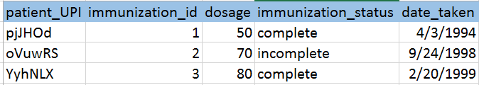

## **3.11 disability_lk**

This entity holds the information about the different types of disabilities that a patient can have. Disability is the consequence of an impairment that may be physical, cognitive, mental, sensory, emotional, developmental, or some combination of these that result in restrictions on an individual's ability to participate in what is considered "normal" in their everyday society. The disability entity serves as a lookup table which benefits in reducing the redundancy of data in scenarios when two or more patients share the same disability.

|  |  |  |  |
| --- | --- | --- | --- |
| **Attribute** | **Constraint/Key** | **Data Type** | **Description** |
| disability_id | NN/PK | Int | This item is the primary identification of the different disabilities that exist in the health care provider’s database. |
| disability_name | NN | Varchar (30) | This item holds the name of the disability like a particular autism, blindness, hair loss, arthritis, etc. |
| disability_type | NN | Varchar (20) | This item holds the type of disability which the patient can have like physical, mental, etc. |

## **Sample Data:**

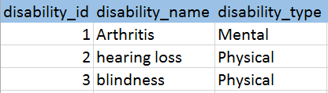

## **3.13 patient_disability**

This entity captures the relationship between patient and the disability the patient has taken. The patient and the disability share a many to many relationship because of which this join table comes into existence. It also captures some other useful details as shown in the table.

|  |  |  |  |
| --- | --- | --- | --- |
| **Attribute** | **Constraint/**  **Key** | **Data Type** | **Description** |
| patient_UPI | NN/PFK | Char (6) | This item captures the foreign key which references to the patient’s detail in the patient table. It also serves as a primary key because this table cannot exist without the patient. |
| disability_id | NN/PFK | Int | This item captures the foreign key which references to the disability’s detail in the disability entity. It also serves as a primary key because this table cannot exist without the patient. |
| disability_percentage | NN | Decimal (4,2) | This item captures the percentage which reflects up-to how much extend the patient has a disability. |

**Sample Data:**

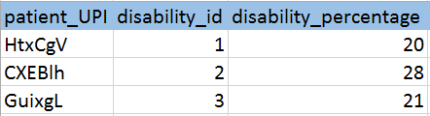

## **3.14 insurance_lk**

An Insurance is a practice or arrangement by which a company or government agency provides a guarantee of compensation for specified loss, damage, illness, or death in return for payment of a premium. This entity holds the information about the different companies that offer insurance. The insurance entity serves as a lookup table which benefits in reducing the redundancy of data in scenarios when two or more patients share the same insurance.

|  |  |  |  |
| --- | --- | --- | --- |
| **Attribute** | **Constraint/Key** | **Data Type** | **Description** |
| company_id | NN/PK | Int | This item is the primary identification of the different companies that provide different types of insurance. |
| company_name | NN | Varchar (40) | This item holds the name of the company that provides the insurance. |

**Sample Data:**

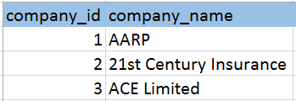

## **3.15 patient_insurance_history**

This entity captures the relationship between patient and the insurance the patient has. The patient and the insurance share a many to many relationship because of which this join table comes into existence. It also captures some other useful details as shown in the table.

|  |  |  |  |
| --- | --- | --- | --- |
| **Attribute** | **Constraint/**  **Key** | **Data Type** | **Description** |
| patient_UPI | NN/PFK | Char (6) | This item captures the foreign key which references to the patient’s detail in the patient table. It also serves as a primary key because this table cannot exist without the patient. |
| company_id | NN/PFK | Int | This item captures the foreign key which references to the insurance company’s detail in the insurance entity. It also serves as a primary key because this table cannot exist without the patient. |
| insurance_number | NN | Char (6) | This item holds the insurance number of the patient. |
| claim_id | NN | Char (6) | This item holds the claim id of the patient. |
| claim_date | NN | Date | This item holds the date from which the coverage starts for the insured. Format - MM/DD/YYYY |
| coverage_date |  | Date | This item holds the date at which the coverage ends for the person insured. Format - MM/DD/YYYY |

**Sample Data:**

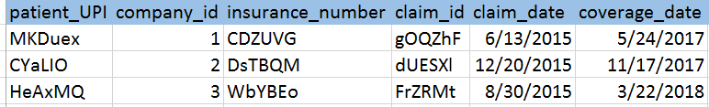

## **3.16 patient_surgery_history**

Surgery table holds the detail of different types of surgery that a patient may have undergone through. A surgery is a treatment of injuries or disorders of the body by incision or manipulation, especially with instruments. The surgery entity serves as a reference table which benefits in reducing the redundancy of data in scenarios when two or more patients have undergone same surgery and hence nullifying duplicity of data.

|  |  |  |  |
| --- | --- | --- | --- |
| **Attribute** | **Constraint/**  **Key** | **Data Type** | **Description** |
| surgery_id | NN/PK | Int | This item is the primary identification of the different surgeries that exist in the health care industry. |
| patient_UPI | NN/PFK | Char (6) | This item captures the foreign key which references to the patient’s detail in the patient table. It also serves as a primary key because this table cannot exist without the patient. |
| surgery_date | NN | Date | This item captures the date at which the surgery was performed on the patient. Format - MM/DD/YYYY |
| sugery_performedby | NN | Varchar (40) | This item holds the information about the medical practitioner’s name who performed the surgery on the patient. |
| surgery_type | - | Varchar (40) | This item holds the different types of surgeries that are performed on patients like colectomy, laparoscopy, mastectomy and many more. |
| surgery_description | - | Varchar (255) | This item consist of the description of the surgery that was undergone. |

**Sample Data:**

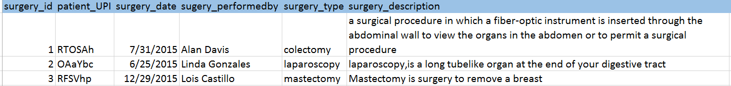

## **3.17 patient_event**

This entity holds the record of all the past, future and present appointments of patient with the medical practitioner or the doctor. This table maintains data like treated doctor, prescription by doctor.

|  |  |  |  |
| --- | --- | --- | --- |
| **Attribute** | **Constraint/**  **Key** | **Data Type** | **Description** |
| event_id | NN/PK | Int | This item is the primary identification of the different events that take place between the patient and the medical practitioner at the health care facility. |
| patient_UPI | NN/PFK | Char(6) | This item captures the foreign key which references to the patient’s detail in the patient table. It also serves as a primary key because this table cannot exist without the patient. |
| doctor_id | NN/PFK | Int | This item captures the foreign key which references to the doctor’s detail in the doctor table. It also serves as a primary key because this table cannot exist without the doctor. |
| event_date | NN/PFK | Date | This item is the primary identification of the events that take place between the doctor and the patient. Format - MM/DD/YYYY |
| event_desc | NN | Varchar (255) | This items holds the primary reason because of which the event has been scheduled between the doctor and the patient. |
| patient_type | NN | Varchar (20) | It is one of the most important attribute of these database model because here it decided whether a patient is just an out-patient (someone who just gave a visit for follow-up, test) or an in-patient (someone who will be admitted in the facility of health care provider) |

**Sample Data:**

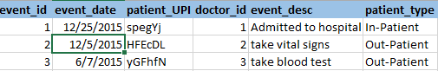

## **3.18 vital_signs**

The clinical measurements, specifically pulse rate, temperature, respiration rate, and blood pressure that indicate the state of a patient's essential body functions are considered to be the vital signs of the patient. The ‘Vital Signs’ entity holds all this information of the patient when he/she visits the health care provider and an event take place between the doctor and the patient.

|  |  |  |  |
| --- | --- | --- | --- |
| **Attribute** | **Constraint/**  **Key** | **Data Type** | **Description** |
| patient_UPI | NN/PFK | Char(6) | This item captures the foreign key which references to the patient’s detail in the patient table. It also serves as a primary key because this table cannot exist without the patient. |
| doctor_id | NN/PFK | Int | This item captures the foreign key which references to the doctor’s detail in the doctor table. It also serves as a primary key because this table cannot exist without the doctor. |
| event_id | NN/PFK | Int | This item captures the foreign key which references to the event’s detail in the patient event table. |
| body_temprature | NN | Decimal (5,2) | This item captures patient’s body temperature at the time of the event. Unit - Celsius |
| pulse_rate | NN | Decimal (3,0) | This item captures patient’s pulse rate at the time of the event. Unit - BPM |
| respiration_rate | NN | Decimal (3,0) | This item captures patient’s respiration rate at the time of the event. Unit – BPM |
| blood_pressure_diastolic | NN | Decimal (3,0) | This item captures patient’s bottom number of blood pressure at the time of the event. Unit - mmHg |
| blood_pressure_systolic | NN | Decimal (3,0) | This item captures patient’s top number blood pressure at the time of the event. Unit - mmHg |
| weight | NN | Decimal (5,2) | This item captures patient’s weight at the time of the event. Unit - lb |

**Sample Data:**

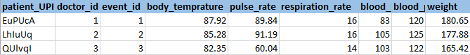

## **3.19 doctor**

The doctor is a qualified practitioner of medicine; a physician or a medical practitioner. A doctor serves the event which is scheduled for the concerned patient at the health care provider facility. This entity is responsible for capturing all the information about the doctor.

|  |  |  |  |
| --- | --- | --- | --- |
| **Attribute** | **Constraint/**  **Key** | **Data Type** | **Description** |
| doctor_id | NN(PK) | Int | This item is the unique identification of the doctor. Thus it is the primary key of this entity. |
| doctor_UPIN | NN | Char(6) | This item captures the UPIN which is Unique Physician Identification Number that is maintained by the US to identify doctors and medical practitioners. |
| doctor_fname | NN | Varchar (20) | This item holds the first name of doctor. |
| doctor_lname | NN | Varchar (20) | This item holds the last name of doctor. |
| doctor_mname |  | Varchar (20) | This item holds the middle name of doctor. |
| doctor_specialization | NN | Varchar (20) | This item captures what type of medical practitioner or doctor the person is which can be cardiologist, pediatrician, gynecologist, etc. |

**Sample Data:**

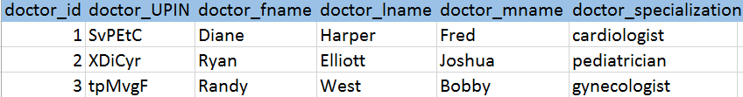

## **3.20 prescription**

Prescription is an instruction written by a medical practitioner that authorizes a patient to be provided a medicine or treatment. Here the prescription entity carries exactly the same information for the patient which is provided by the doctor or medical practitioner.

|  |  |  |  |
| --- | --- | --- | --- |
| **Attribute** | **Constraint/**  **Key** | **Data Type** | **Description** |
| prescription_id | NN/PK | Char (6) | This item is the primary identification of prescription that is given to the patient by the medical practitioner during the event. |
| patient_UPI | NN/PFK | Char (6) | This item captures the foreign key which references to the patient’s detail in the patient table. It also serves as a primary key because this table cannot exist without the patient. |
| doctor_id | NN/PFK | Int | This item captures the foreign key which references to the doctor’s detail in the doctor table. It also serves as a primary key because this table cannot exist without the doctor. |
| event_id | NN/PFK | Int | This item captures the foreign key which references to the event’s detail in the patient event table. |
| drug_NDC | NN/PFK | Int | This item captures the information about the drug that has been prescribed to the patient by the medical practitioner. |
| drug_dosage | NN | Varchar (20) | This item contains the information about the drug dosage that is recommended to the patient by the medical practitioner. |
| doctor_notes | - | Varchar (255) | This item captures all the instructions which the doctor gives to the patient. |

**Sample data:**



## **3.21 medication_lk**

Medication is a substance used for medical treatment, especially a medicine or drug. This entity holds the record of different drugs and their characteristics as well as the whether they are approved by the national organization or not.

|  |  |  |  |
| --- | --- | --- | --- |
| **Attribute** | **Constraint/**  **Key** | **Data Type** | **Description** |
| drug_NDC | NN/PK | Int | This item is the unique identification of the drug and NDC is the National Drug Code that is maintained by US FDA. This can help the health care provider in case of checking authenticity of the drug and to get information about the drug from the database maintained by US FDA. |
| drug_name | NN | Varchar(30) | This item holds the information about the Drug or medication name. |
| drug_form | NN | Varchar(20) | This item holds the information about the drug form which can be either tablet, capsule, liquid, etc. |
| drug_strength | NN | Int | This item holds the information about the strength of the drug’s strength which will be stored in mg (milligram). |

**Sample Data:**

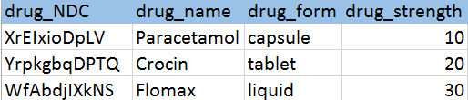

## **3.22 treatment**

This entity holds the information about the treatment that has been prescribed by the doctor to be done within the health care provider’s facility.

|  |  |  |  |
| --- | --- | --- | --- |
| **Attribute** | **Constraint/**  **Key** | **Data Type** | **Description** |
| patient_UPI | NN/PFK | Char (6) | This item captures the foreign key which references to the patient’s detail in the patient table. It also serves as a primary key because this table cannot exist without the patient. |
| doctor_id | NN/PFK | Int | This item captures the foreign key which references to the doctor’s detail in the doctor table. It also serves as a primary key because this table cannot exist without the doctor. |
| event_id | NN/PFK | Int | This item captures the foreign key which references to the event’s detail in the patient event table. |
| treatment_desc | - | Varchar (255) | This item holds the description about the treatment that conducted on the patient. |
| procedure_id | FK | Int | This item captures the foreign key which references to the procedure in the procedure table. It also serves as a primary key because this table cannot exist without the doctor. |

**Sample Data:**

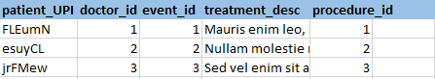

## **3.23 patient_surgery_details**

This entity holds the surgery information that was conducted on the patient within the healthcare provider’s facility.

|  |  |  |  |
| --- | --- | --- | --- |
| **Attribute** | **Constraint/**  **Key** | **Data Type** | **Description** |
| patient_UPI | NN/PFK | Char (6) | This item captures the foreign key which references to the patient’s detail in the patient table. It also serves as a primary key because this table cannot exist without the patient. |
| doctor_id | NN/PFK | Int | This item captures the foreign key which references to the doctor’s detail in the doctor table. It also serves as a primary key because this table cannot exist without the doctor. |
| drug_form | NN | Varchar(20) | This item holds the information about the drug form which can be either tablet, capsule, liquid, etc. |
| event_id | NN/PFK | Int | This item captures the foreign key which references to the event’s detail in the patient event table. |
| surgery_note | - | Varchar (255) | This item holds the information about the surgery. |
| surgery_start_time | NN | Datetime | This item holds the date at which the surgery started. Format - yyyy-mm-dd hh:mm:ss |
| surgery_end_time | NN | Datetime | This item holds the date at which the surgery ended. Format - yyyy-mm-dd hh:mm:ss |
| procedure_id | FK | Int | This item captures the foreign key which references to the procedure in the procedure table. It also serves as a primary key because this table cannot exist without the doctor. |

**Sample Data:**

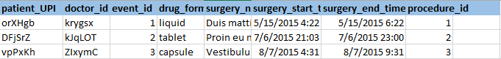

## **3.24 procedure_lk**

This entity holds the information about the procedure that is done on the patient at the health care provider’s facility. This entity serves as a lookup table which benefits in reducing the redundancy of data in scenarios when two or more patients have been involved in the same treatment or surgery that has the same procedure.

|  |  |  |  |
| --- | --- | --- | --- |
| **Attribute** | **Constraint/Key** | **Data Type** | **Description** |
| procedure_id | NN/PK | Int | This item is the primary identification of the different types of procedure that are offered by the healthcare provider. |
| procedure_desc | NN | Varchar (255) | This item holds the information about how the procedure must be done in detailed manner. |

**Sample Data:**

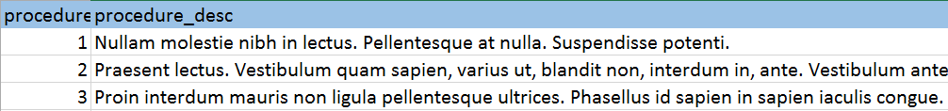

## **3.25 lab_test_history**

This entity holds the information about the laboratory test that is conducted on the patient at the health care provider’s facility.

|  |  |  |  |
| --- | --- | --- | --- |
| **Attribute** | **Constraint/**  **Key** | **Data Type** | **Description** |
| patient_UPI | NN/PFK | Char (6) | This item captures the foreign key which references to the patient’s detail in the patient table. It also serves as a primary key because this table cannot exist without the patient. |
| doctor_id | NN/PFK | Int | This item captures the foreign key which references to the doctor’s detail in the doctor table. It also serves as a primary key because this table cannot exist without the doctor. |
| event_id | NN/PFK | Int | This item captures the foreign key which references to the event’s detail in the patient event table. |
| time_reported | - | Datetime | This item holds the date and time at which the test was reported. Format - yyyy-mm-dd hh:mm:ss |
| time_collected | - | Datetime | The item holds the date and time at which the report was collected. Format - yyyy-mm-dd hh:mm:ss |
| result | - | Varchar (20) | This item holds the result of the test which can either be positive or negative or some value. |
| status | - | Varchar (10) | This item holds the information about the status which can be either normal, below or average. |
| test_id | NN/FK | Int | This item captures the foreign key which references to the test’s detail in the test table. It also serves as a primary key because this table cannot exist without the doctor. |

**Sample Data:**

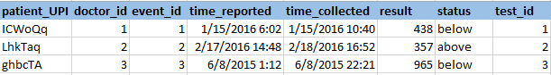

## **3.26 lab_test_lk**

This entity holds the information about the laboratory test that is conducted on the patient at the health care provider’s facility. This entity serves as a lookup table which benefits in reducing the redundancy of data in scenarios when two or more patients have taken the same test.

|  |  |  |  |
| --- | --- | --- | --- |
| **Attribute** | **Constraint/Key** | **Data Type** | **Description** |
| test_id | NN/PK | Int | This item is the primary identification of the different types of test that are offered by the healthcare provider. |
| test_description | NN | Varchar (255) | This item holds the description of the test conducted on the patient. |
| test_type | NN | Varchar (20) | This item holds the type of test which can be either blood test, urine test, etc. |
| above_optimal | NN | Int | This item holds the upward limit value of a particular type of test. |
| below_optimal | NN | Int | This item holds the downward limit value of a particular type of test. |

**Sample Data:**

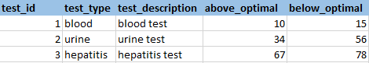

## **3.27 lab_test_images**

This entity holds the information about the laboratory test images that is conducted on the patient at the health care provider’s facility.

|  |  |  |  |
| --- | --- | --- | --- |
| **Attribute** | **Constraint/**  **Key** | **Data Type** | **Description** |
| patient_UPI | NN/PFK | Char (6) | This item captures the foreign key which references to the patient’s detail in the patient table. It also serves as a primary key because this table cannot exist without the patient. |
| doctor_id | NN/PFK | Int | This item captures the foreign key which references to the doctor’s detail in the doctor table. It also serves as a primary key because this table cannot exist without the doctor. |
| event_id | NN/PFK | Int | This item captures the foreign key which references to the event’s detail in the patient event table. It also serves as a primary key because this table cannot exist without an event. |
| test_image | NN | Varchar (255) | This item contains lab test images which can be for example x-ray images. |

**Sample Data:**

## **3.28 bed_assignment**

The ‘bed_assignment’ entity holds all the information about the type of facility room and bed the health care provider provides to the patient who is admitted with it.

|  |  |  |  |
| --- | --- | --- | --- |
| **Attribute** | **Constraint/**  **Key** | **Data Type** | **Description** |
| bed_assignment_id | NN/PK | Int | This item is the primary identification of the bed present at the facility of the health care provider. |
| bed_number | NN | Int | This item is the primary identification of the bed present at facility of health care provider. |
| patient_UPI | NN/PFK | Char (6) | This item captures the foreign key which references to the patient’s detail in the patient table. It also serves as a primary key because this table cannot exist without the patient. |
| doctor_id | NN/PFK | Int | This item captures the foreign key which references to the doctor’s detail in the doctor table. It also serves as a primary key because this table cannot exist without the doctor. |
| event_id | NN/PFK | Int | This item captures the foreign key which references to the event’s detail in the patient event table. |
| date_from | NN | Date | This item captures the date from which the patient is admitted into the facility of the health care provider.at which the event takes place between the doctor and the patient. Format - MM/DD/YYYY |
| date_till | NN | Date | This item captures the date till which the patient is admitted into the facility of the health care provider. Format - MM/DD/YYYY |
| ward_type | NN | Varchar (20) | This item captures the information about the type of the room the patient is present in like ICU, operating room, recovery room, emergency trauma room. |

**Sample Data:**

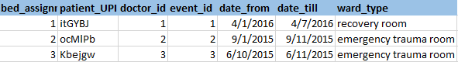

# **4. Relationships**

## **4.1 patient_has_address**

* **Assumption**: Same address can belong to multiple patients.
* This is a relationship between patient and address.
* The relationship between these two entities is a non-identifying relationship because an address can exist in the database without the patient.
* Here address is the parent entity and patient is the child entity.
* Address shares a 1: N relationship with patient because an address can belong to multiple patients.

## **4.2 patient_has_socialhabits**

* **Assumption**: Patient may/may not share his social habits to the health care provider.
* This is a relationship between patient and social_habits.
* The relationship between these two entities is an identifying relationship because a patient_UPI is required to map patient with his social habits.
* Here patient is the parent entity and social_habits is the child entity.
* Patient shares a 1:1 or 1:0 relationship with social_habits because each patient can have only one or no social habits.

## **4.3 patient_has_familyhistory**

* **Assumption**: Patient may/may not share his family history to the health care provider.
* This is a relationship between patient and family_history.
* The relationship between these two entities is an identifying relationship because a patient_UPI is required to map patient with his family.
* Here patient is the parent entity and family_history is the child entity.
* Patient shares a 1:1 or 1:0 relationship with family_history because each patient can have only one or no family history information.

## **4.4 patient_has_healthproxy**

* **Assumption**: Patient has a healthcare proxy.
* This is a relationship between patient and health_care_proxy.
* The relationship between these two entities is an identifying relationship because a patient_UPI is required to map patient with his health care proxy.
* Here patient is the parent entity and health_care_proxy is the child entity.
* Patient shares a 1:1 or 1:0 relationship with health_care_proxy because each patient can have one or no health care proxy.

## **patient_has_allergy**

* **Assumption:** Patient may or may not have Allergy.
* This is a relationship between patient and allergy entity.
* It is assumed that a patient may have 0 or many Allergies. And it goes vice-a-versa too, single Allergy can be prevalent in many patient.
* There is a many to many relationship between patient and allergy.
* We require a bridging table called patient_allergy which takes both the primary keys i.e. patient_UPI from patient and allergy_id from allergy that helps to map this relation.

## **4.6 patient_has_disease**

* **Assumption:** Patient may or may not have disease in the past.
* This is a relationship between patient and disease entity.
* It is assumed that a patient may have 0 or many disease. And it goes vice-a-versa too, single disease can be prevalent in many patient.
* There is a many to many relationship between patient and disease.
* We require a bridging table called patient_disease_summary which takes both the primary keys i.e. patient_UPI from patient and disease_id from allergy that helps to map this relation.

## **4.7 patient_is_immuned**

* **Assumption**: Patient has taken immunization in the past.
* This is a relationship between patient and immunization.
* It is assumed that a patient may have 0 or many immunizations taken in the past. And it goes vice-a-versa too, single immunization can be prevalent in many patient.
* There is a many to many relationship between patient and immunization.
* We require a bridging table called patient_immunization which takes both the primary keys i.e. patient_UPI from patient and disease_ICD_10 from disease table that helps to map this relation.

## **4.8 patient_has_disability**

* **Assumption:** Patient may/may not have any type of disability.
* This is a relationship between disability and patient_disability.
* The relationship between these two entities is an identifying relationship because a disability is required to map with patient in patient_disability table.
* Here disability is the parent entity and patient_disability is the child entity.
* A patient may or may not have any sort of disability.
* Disability shares a 1:N relationship with patient_disability because an disability can belong to multiple patient.

## **4.9 patient_has_insurance**

* **Assumption:** Patient may/may not have any insurance.
* This is a relationship between patient and insurance.
* It is assumed that a patient may have 0 or many insurances in the past. And it goes vice-a-versa too, single insurance can be prevalent in many patients.
* There is a many to many relationship between patient and insurance.
* We require a bridging table called patient_insurance_history which takes both the primary keys i.e. patient_UPI from patient and company_id from insurance table that helps to map this relation.

## **4.10 patient_undergoes_surgery**

* **Assumption:** Patient may/may not have undergone any surgery.
* This is a relationship between patient and patient_surgery_history entities.
* The relationship between these two entities is an identifying relationship because a disability is required to map with patient in patient_disability table.
* Here patient is the parent entity and patient_surgery_history is the child entity.
* A patient may or may not have undergone any sort of surgery.
* Patient shares a 1:N relationship with patient_surgery_history because might have undergone no or multiple surgeries.

## **4.11 patient_has_event**

* **Assumption:** Patient have come to hospital for some service.
* This is a relationship between patient and patient_event.
* The relationship between these two entities is an identifying relationship because a patient_UPI is required to map patient with his events in hospital.
* Here patient is the parent entity and patient_event is the child entity.
* Patient shares a 1: N relationship with patient_event because each patient can have at-least one to many events in a hospital.

## **4.12 doctor_serves_event**

* **Assumption:** A doctor always serve patient in a hospital.
* This is a relationship between doctor and patient_event.
* The relationship between these two entities is an identifying relationship because a doctor is always required to serve patient.
* Here doctor is the parent entity and patient_event is the child entity.
* Doctor shares a 1:1 relationship with patient_event because each doctor can serve single patient at a particular instance of time of event.

## **4.13 patient_has_vitals**

* **Assumption:** A doctor has recorded patient vital signs during patient’s visit.
* This is a relationship between patient_event and vital_signs.
* The relationship between these two entities is an identifying relationship because a patient is required to check his vital signs.
* Here patient_event is the parent entity and vital_signs is the child entity.
* Patient_event shares a 1:1 relationship with vital_signs because vital signs of patient has to be checked by doctor in every visit captured at a particular timestamp.

## **4.14 patient_given_prescription**

* **Assumption:** Patient is provided a prescription from doctor.
* This is a relationship between patient and prescription.
* The relationship between these two entities is an identifying relationship because a patient is required to provide prescription by doctor.
* Here patient is the parent entity and prescription the child entity.
* Patient shares a 1:1 or 1: N relationship with prescription because a doctor prescribes one or many prescription to the patient.

## **4.15 prescription_has_medication**

* **Assumption:** Every prescription has medication provided to patient.
* This is a relationship between prescription and medication.
* The relationship between these two entities is a non-identifying relationship because a medication do exist in the hospital even if is not mentioned in any prescription.
* Here medication is the parent entity and prescription the child entity.
* Medication shares a 1:1 or 0:1 relationship with prescription because every prescription should contain only one medication.

## **4.16 patient_undergoes_treatment**

* **Assumption:** Every patient may or may not undergo any treatment at the health care provider’s facility.
* This is a relationship between patient and treatment.
* The relationship between these two entities is an identifying relationship because a medication is required in every prescription.
* Here medication is the parent entity and prescription the child entity.
* Patient shares a 1:0 or 1:N relationship with treatment because every patient may undergo none, single or multiple treatments at the facility.
* The treatment table uses the procedure_lk table as the lookup for information about how the treatment should be carried out.

## **4.17 patient_undergoes_surgery**

* **Assumption:** Every patient may or may not undergo any surgery at the health care provider’s facility.
* This is a relationship between patient and patient_surgery_details.
* The relationship between these two entities is an identifying relationship because a patient_UPI is required to map a relationship with the patient_surgery_details entity.
* Here patient is the parent entity and patient_surgery_details is the child entity.
* Patient shares a 1:0 or 1:1 relationship with surgery because every patient may undergo none or single surgery at the facility.
* The patient_surgery_details table uses the procedure_lk table as the lookup for information about how the surgery should be carried out.

## **4.18 patient_gives_labtest**

* **Assumption:** Every patient may or may not undergo any lab-test at the health care provider’s facility.
* This is a relationship between patient and lab_test_history.
* The relationship between these two entities is an identifying relationship because a patient_UPI is required to map a relationship with the lab_test_history entity.
* Here patient is the parent entity and lab_test_history is the child entity.
* Patient shares a 1:0 or 1:N relationship with lab test because on every patient may be told none or single or many lab test at the facility.
* The lab_test_history table uses the lab_test_lk table as the lookup for information about how the test must be performed and the type of test.

## **4.19 patient_has_bedassigned**

* **Assumption:** Patient came to health care provider for treatment, etc. and stayed at the facility overnight and a bed was assigned to him.
* This is a relationship between in_patient (type of patient captured in the event entity) and bed_assignment.
* The relationship between these two entities is a non-identifying relationship because a patient_UPI is not required to map a bed at the facility.
* Here in_patient is the parent entity and bed_assignment the child entity.
* Patient shares a 0:0, 0:1 or 0:N relationship with bed_assignment because a bed has to be assigned to all in patients, and not be assigned to out_patient and an in_patient can shift bed while stay at the facility.

# **5. Glossary of Terms**

|  |  |
| --- | --- |
| **Term** | **Description of the term** |
| UPI | Unique Patient Identification |
| DOB | Date of Birth |
| ICD-10 | International Classification of Disease |
| UPIN | Unique Physician Identification Number |
| NDC | National Drug Code |
| Fname | First Name |
| lname | Last Name |
| mname | Middle Name |
| Id | Identifier |
| PCP | Primary Care Physician |

**Data Model 1.0**

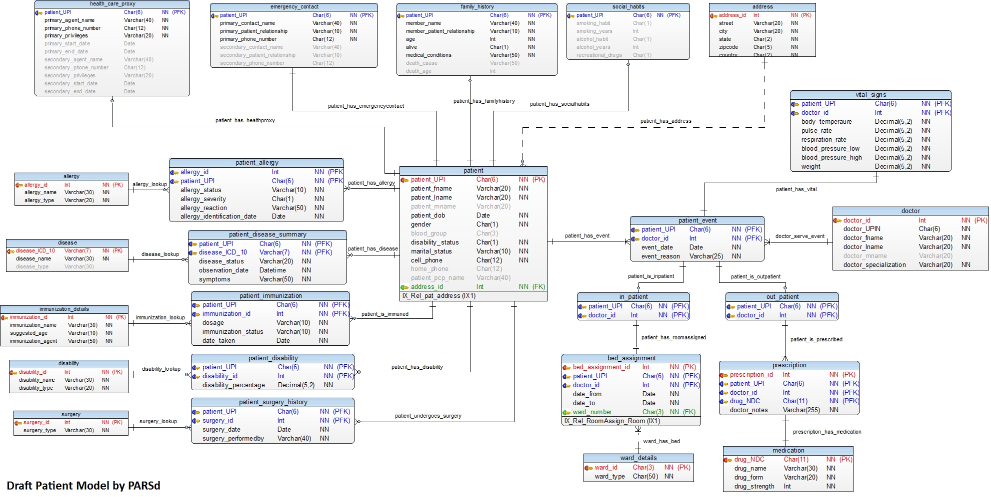

**Data Model 1.1**

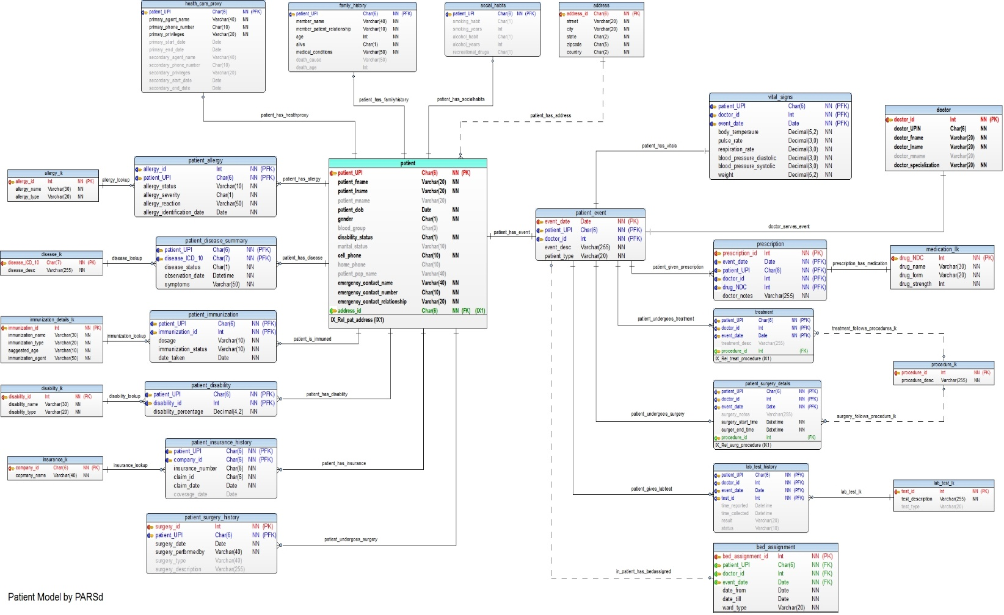

**Data Model Final**

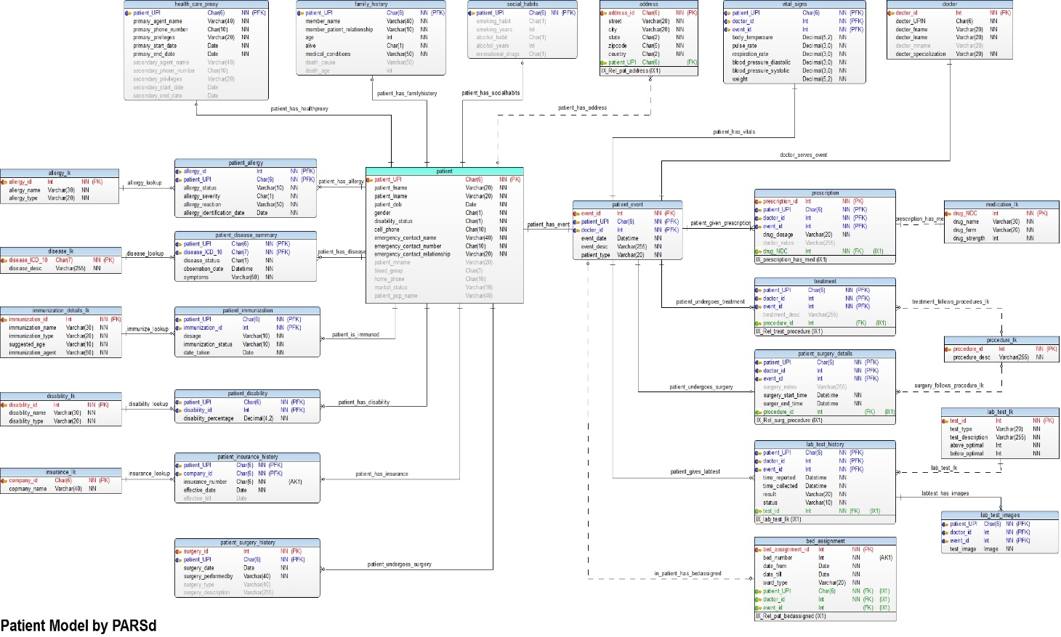

**End of Document**